**DEHAZING AND HAZING USING MATLAB**

Y. Hemanth#1, Vijay gopu#2, G. Praveen #3

==

***Abstract*—** **Recently the most role and verywidly application fields have been seen in computer vision and graphics visualization, Computer vision applications are extinctly impaired when weather is unfavorable, which typically caused reducing visibility in capturing the clear images. In image processing techniques and contexts, hazing is a surrounding condition that effects scene objects clarity, attributed to the influence of moisturised in the atmosphere. Haze worsens clarity of scene objects, which consequently impacts the computer vision and also the graphic applications negatively. Here the role of the dehazing method still it is very vital in computer vision applications, it can make images more clear and oftenly used by taking off, haze from them, thus the scene vision will be incremented . From earlier up to now current scenerio, many methods have been proposed and methodology for improving images. The single image dehazing techniques and hazing images is one of them and recently the researchers are more interested and also widely used in this method. The primary contributions of this review study focus on explaining the cause of haze formation for images more clearly, general historical ,overview of single image ,dehazing methods, and also the hazing techniques explains the most equation used in the dehazing process those help to contributing the newly used methods to remove hazing and clarify the hazy image, and clarify the pros and cons of haze removal methods.**

**Keywords: Hazy Image, Dehazing Methods, Haze Removal Techniques, Single Image Dehazing, Multiple Image Dehazing, Outdoor Image, Image Restoration, Image Enhancement, Image Fusion Based, Dark Channel, Deep Learning-Based.**

1. Introduction

Haze in atmosphere is an observable fact that obscures the cleanliness of the sky. Most of the impurities in air ranges below 1000m. Atmospheric impurities are mist, fog, and smog and some amount of dust. Haziness is caused due to impurities in air due to the secondary conditions. This occurs in many populated areas like industrial areas and also big metropolitian cities. Due to the haze clarity of images will be degraded. Haziness consists of "Airlight" and "Direct attenuation" That is Haze = Attenuation + Airlight . Increasing in the consumption due to industrial production and human activities , the concentration of atmospheric particulate matter (PM) present in the atmosphere had considerably increased, leading to the frequently occurrence of fog and haze in the atmosphere. The atmosphere carries limitlessly particles like dust and water droplets and particular amount of another particles , which deflects the light rays from their original path of propagation. This deflection effects the increase of especially in bad weather conditions like haze, rain and snow. Limited visibility due to presence of fog and haze is a big issue for many vehicle surveillance applications in the morning times due to reduced visibility, little contrast, faint brightness, shortened luminance and inaccurate color , which makes detection of objects more difficult in fog and haze . So, removal of haze or dehazing techniques from the images captured has been an important task in computer vision algorithms .The process of removing haze from an image called de-hazing, and the vice versa process is hazing and it is an inevitable task because haze-free images are visually pleasing and improve the performance of computer vision tasks .

1. LITERATURE REVIEW

**Shabna, Mr.C.S.ManikandaBabu (2019)**

Hazing could be a main degradation of outdoor images as well as the another images, both colors and contrasts, resulting in the fact that light is absorbed and scattered by the turbid medium such as particles and water droplets in the atmosphere during the process of propagation is explained in this paper. Moreover in most automatic systems it explains , which strongly depends on the definition of the input images, this may fail to working conditions normally caused by the degraded images. Early researches uses a traditional techniques to remove haze from the single image in image processing and also viceversa. First, uses a histogram based dehazing effect is limited because, it possibly losses the infrequently distributed pixels in the intensity due to global processing of the image on the entire image, and also the histogram modification technique is difficult to implement in real time applications due to large amounts of computational and storage requirements. Later, many researches try and improve the dehazing impact with multiple pictures in hazing . In Polarization techniques mostly strategies are used for dehazing impact with multiple pictures, during this polarization pictures will take away the visual effects of hazing . This technique could fail in things of fog and dust or terribly dense haze. The conventional image enhancement techniques are not useful in this method since the effects of weather must be modelled by using atmospheric scattering principles that are closely tied to scene depth.

**Sajana M Iqbal, MuhammadNizar (2019)**

In the recent study on the different haze removal techniques, hazing brings trouble to many computer vision/graphics applications as it diminishes the visibility of the scenes. Hazing is made attributable to the elementary phenomena that are attenuation and also the air light weight. Haze removal techniques recover the colour and contrasting of the scene. The overall objective of this paper is to explore the various methods for efficiently removing of the hazing from the digital images. Haze is historically associate degree of physical phenomenons during which smoke and alternatively the dry particles obscure the clarity of the scenery objects. Environmental illuminations tends to be scattered by this kind of turbid medium and the white air light is formed. It turns out that images taken in such bad weather conditions are often much brighter and the colour of the scenery object fades in different degree. Experimental results shows that the projected approaches which achieves dramatically high and outstanding dehazing result as well .

**Manjunath.V, Revanasiddappa Phatate (2018),**

Simple but effectively prior is called change of detail algorithm for single image dehazing techniques . This algorithm is based on the multiple scattering phenomenas so the input image becomes more blur . When this technique is combined with the hazing imaging model, single dehazing technique becomes easy and effective. This algorithm is based on local content rather than colour and this can be applied to many large variety of images. To overcome this drawback a lot of physical models is taken into consideration. Imaging in inclement weather is often flyblown by dispersion because of suspended particles within the layer like haze , fog and mist and some of the particular dust .

**Manpreet kaur saggu and satbir singh (2020)**

The general objective of this paper is to explore the short comings of the earlier presented techniques used in the revolutionary era of image processing techniques . The deterioration of the image may be due to various factors like relative object-camera motions , blurring due to camera misfocused, relative atmospheric violent features . In this paper we are discussing about the degradation techniques due to bad weather such as fog, haze in an image and the viceversa. This incidence influenced the traditional work of automatic (mechanized) observance system, outdoor recognition system and sensible installation. Scattering is caused by two basic phenomena such as attenuation and air light. By the usage of effective haze or fog removal of image which improves the stability and robustness of the visual systems. Under water image enhancement based techniques become more useful for many vision applications. It is found that largely the prevailing researchers have neglected several issues; that is no technique is precise for various kinds of circumstances. The existing techniques have neglected the employment of dark channel method before scale back the noise and uneven illuminaion downside. To overcome the issues of existing analysis a brand new integrated rule are going to be projected in this paper.

1. Proposed Methodology

A MATLAB GUI is a figure window to which we add user-operated controls . GUI is designed to integrate many image processing functions. A good GUI can make programs easier to use by providing them with a consistent appearance and with intuitive controls like buttons, list boxes .We can select, resize and position the components at any location. Using callbacks the components perform the required task when the user clicks or manipulates them with keystrokes. We can build MATLAB GUIs in two ways: i) Use GUIDE (GUI Development Environment), an interactive GUI construction kit. ii) Create code files that generate GUIs as functions or scripts (programmatic GUI construction). The first approach starts with a figure that we populate with components from within a graphic layout editor. GUIDE creates an associated code file containing callbacks for the GUI and its methods.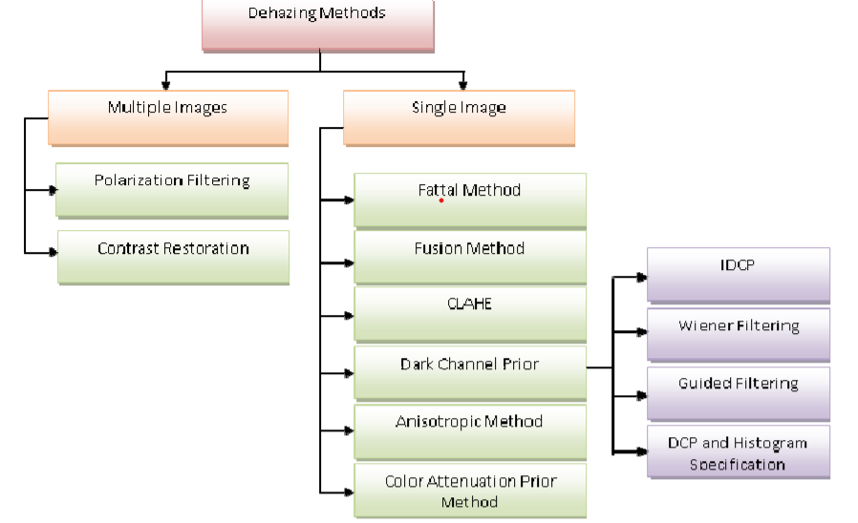

**Dark Channel Prior(DCP)** :

proposed a dark channel prior based methodology and was one of the most widely technique till now. The authors assumed that most local patches in non-sky region had low intensity in one of the color channel and then thickness of haze was accessed from it and finally it was used to restore the output image. The low intensity was usually due to colorful objects and surfaces. Many variants of the said technique had been widely used till now. Some of the variant techniques of the DCP technique are used.

**Guided Filtering:** using another DCP variant with guided image filtering particularly for applications when the large grey area was similar to the global air light. The output haze free image was also good at edge preservation

1. RESULTS AND DISCUSSIONS

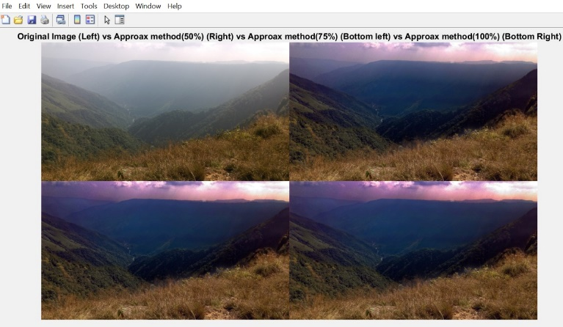

In the above given image the input image is fogged so other 3 output images are de fogged and applied some filters to make it more clear and visible.

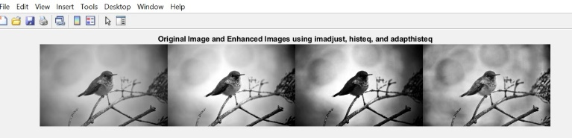 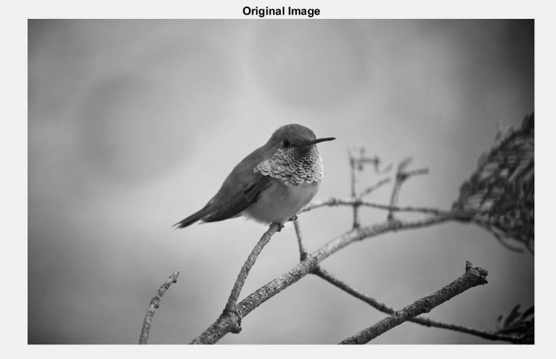 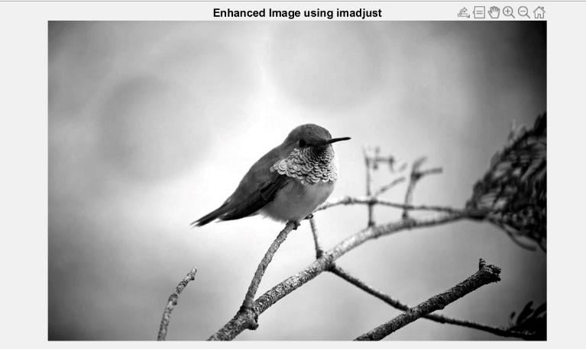 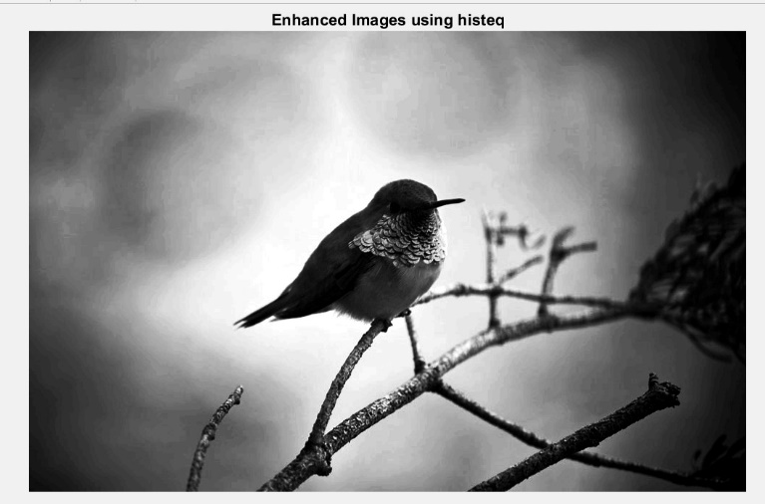 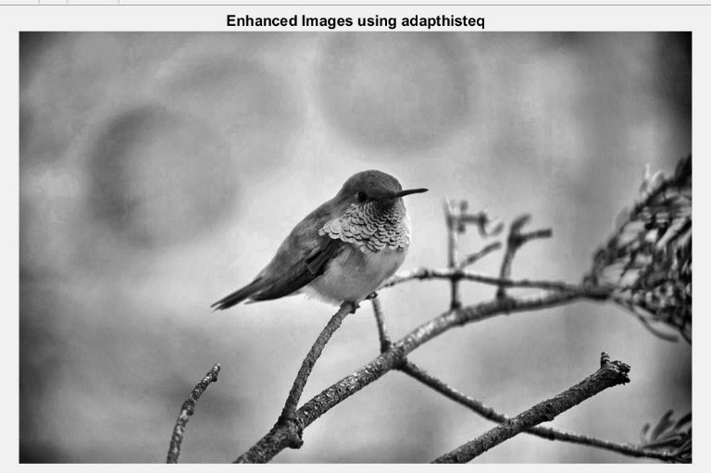 The given image in bird is not so clear it looked smooth and edges are very thin so we applied some enhanced images to make it more visible and to make the edges more sharp and smoothened

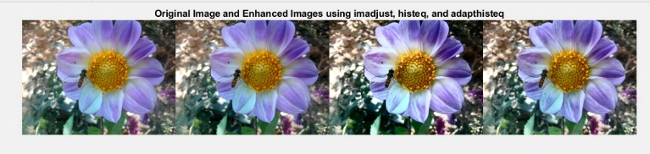 The image is enhanced using imadjust histeq and adapthiseteq and then image got smoothened with more clear object 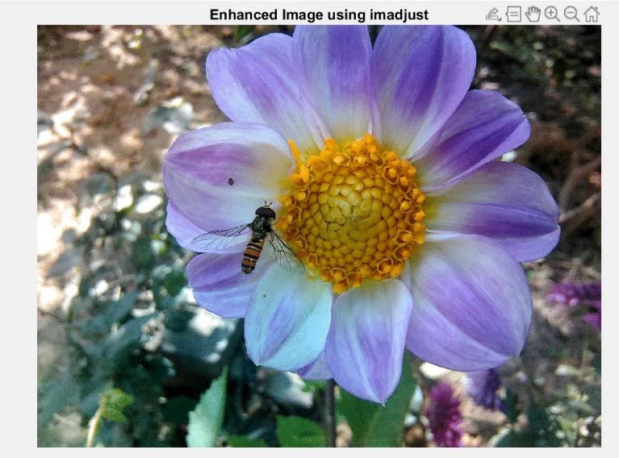 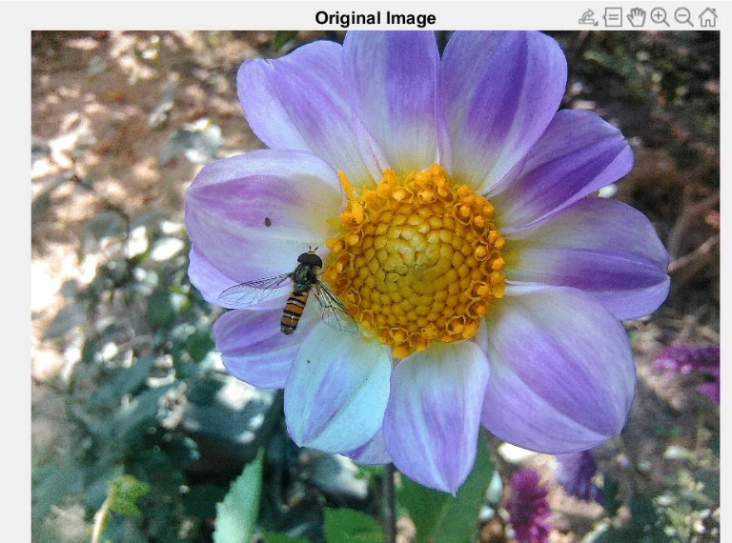 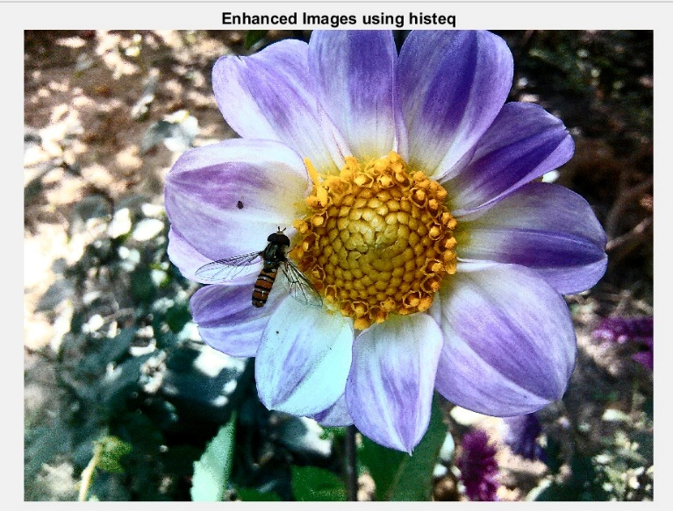

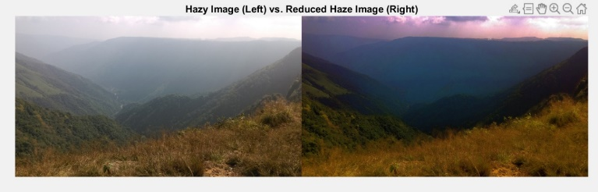 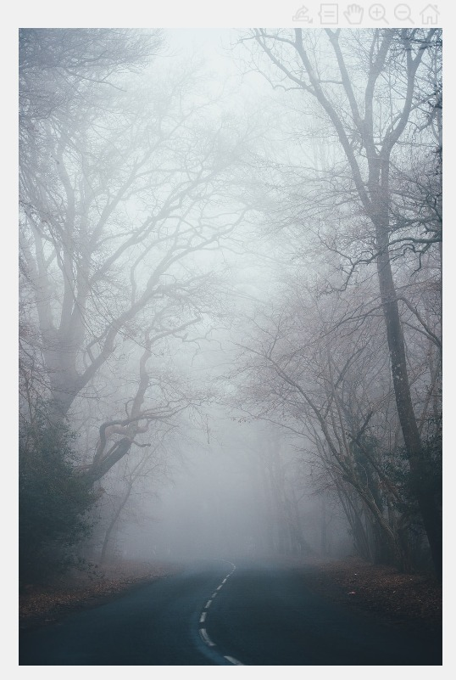 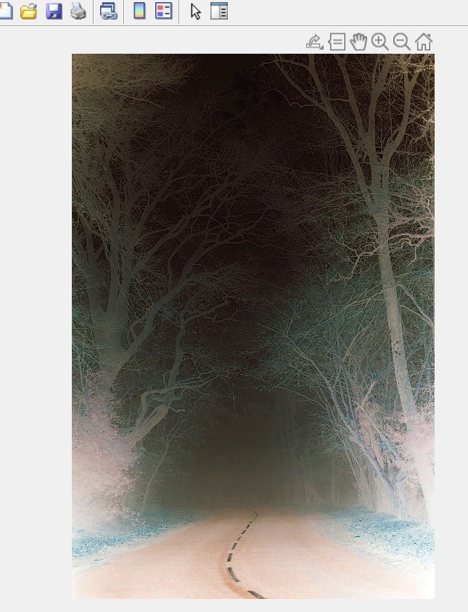 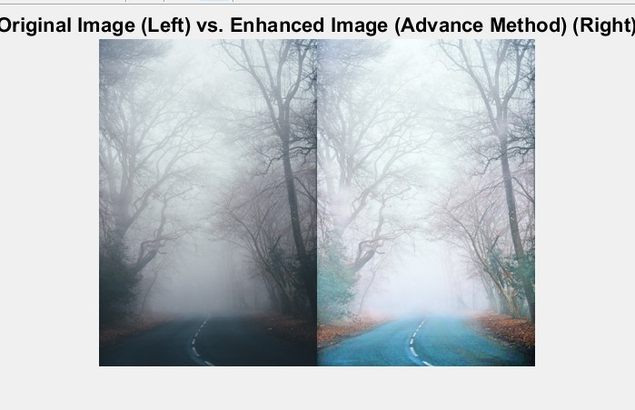

The above given image is filled with fog to make it clear for visible road we applied hazing techniques to remove all the fog and noise it makes road clear and visible

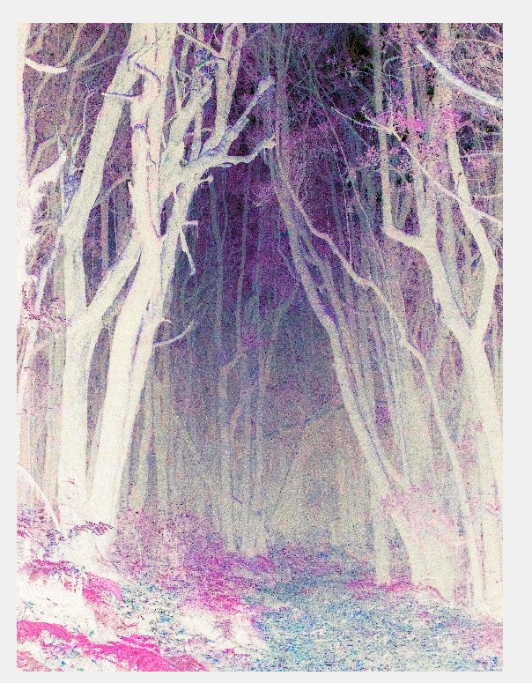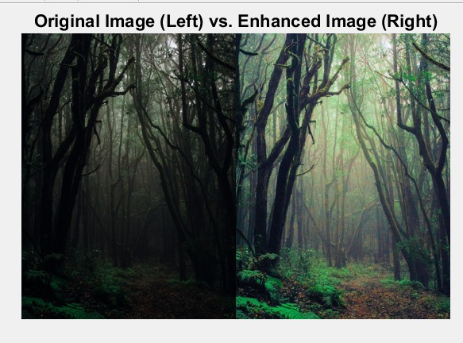

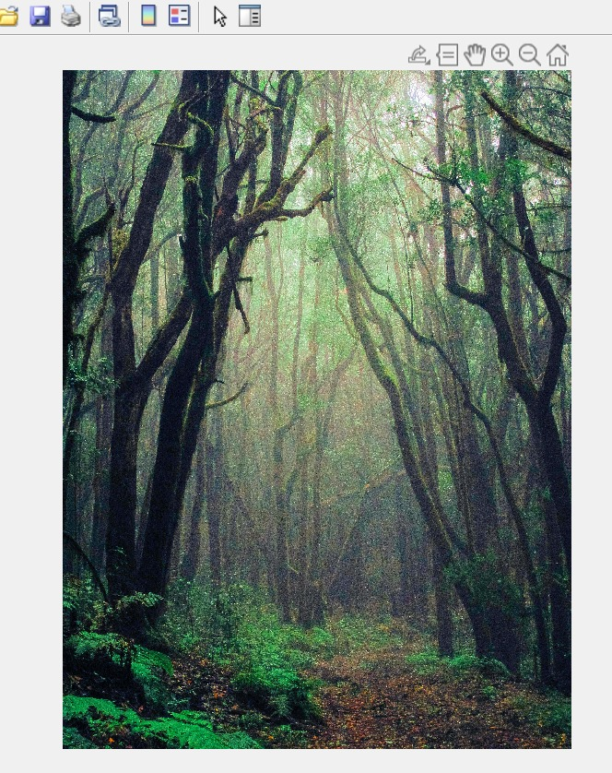

The image in the left looks very dark because of some fog and dehaze in the image after removing it my de fogging and dehazing we applied filter to make the forest more clear and very visible

1. Conclusion

This paper attempts to insight various image dehazing techniques and also the hazing and employed all of them on MATLAB2020. Although a lot of research had been done in the related fields but it still has space to cover more on the present scenerios. The performance evaluations used are PSNR, MSE and NAE. It has b,een found that using WDC technique along with fusion has drawn more favourable results then using alone fusion techniques . For the future work it has been observed that no appropriate techniques can be hundred percent compresed and dehazed. Negligible a lot of work has been attempted in this context. Moreover, generally, the haze free images ,still suffer from basic problems of noise and halos. So, an attempt can be made to remove the noise problems.

The role of dehazing methods in the present situation is very bright in recent years because one of the most important fields appears to be more valuable for many vision applications, so there are many applications available concerning and overcoming the field of computer vision and graphics depend on these methods. It can dislocation haze from the pictures, increment the scene vision. Several dehazing techniques have been used from beginning up to now to remove the haze and improve images, and recently become most filed the researchers concerned. So, the dehazing technique has a major role to solve these kinds of problems. This survey contributes to explain the cause of haze formation, the summary introduction to image enhancement and restoration algorithms and their associated methods, and learning about hazy image’s characteristics and many problems whereas catching an image. But each and every algorithm has certain details and characteristics that distinguish it from other algorithms..

1. References

[1] Y. Song, J. Li, X. Wang, and X. Chen, “Single Image Dehazing Using Ranking Convolutional Neural Network,” IEEE Transactions on Multimedia, 2017.

[2] Z. Rong and W. L. Jun, “Improved wavelet transform algorithm for single image dehazing,” Optik-International Journal for Light and Electron Optics, vol. 125, no. 13, pp. 3064–3066, 2014..

[3] K. He, J. Sun, and X. Tang, “X.: Single image haze removal using dark channel prior,” 2009.

[4] A. K. Tripathi and S. Mukhopadhyay, “Single image fog removal using anisotropic diffusion”, IET Image Process, vol. 6, no. 7, pp. 966–975, 2012.

[5] W. Wang and X. Yuan, “Recent advances in image dehazing,” 2017.

[6] www.mathworks.in.